WEB TECHNOLOGY LAB

EXP.NO: 8

AIM:
To develop an Online Help Desk Support System using HTML, CSS, and JavaScript that allows users to submit IT support tickets, assign categories and priorities, and track ticket status dynamically in a tabular format.

ALGORITHM:
- Open a text editor or IDE (VS Code, Notepad++).
- Create a new file named index.html.
- Define the HTML structure with <head> and <body> sections.
- In the <head>, write CSS styles for the header, form card, table, and status badges.
- In the <body>, create a header section with the application title.
- Add a form card with input fields: Full Name, Email, Category (dropdown), Priority (dropdown), and Issue Description (textarea).
- Add a Submit Ticket button that calls the submitTicket() JavaScript function on click.
- Create a second card with an HTML table to display submitted tickets (Ticket ID, Name, Category, Priority, Status, Update Status).
- In the <script> section, declare a tickets array and a ticketCount variable.
- Write the submitTicket() function to validate all fields, generate a unique Ticket ID (TKT-001, TKT-002...), push the ticket object into the array, and call renderTable().
- Write the changeStatus() function to find a ticket by ID and update its status.
- Write the renderTable() function to dynamically build table rows with color-coded priority classes and status badges.
- Save the file as index.html and open it in any web browser to run the application.

PROGRAM:

index.html

<!DOCTYPE html>
<html lang="en">
<head>
<meta charset="UTF-8">
<meta name="viewport" content="width=device-width, initial-scale=1.0">
<title>Online Help Desk Support System</title>
<style>
* { box-sizing: border-box; margin: 0; padding: 0; }
body { font-family: Arial, sans-serif; background: #f0f4f8; color: #333; }
header {
background: #1565C0; color: white;
padding: 16px 24px;
}
header h1 { font-size: 22px; }
.container {
max-width: 900px; margin: 30px auto; padding: 0 16px;
}
.card {
background: white; border-radius: 8px; padding: 24px;
box-shadow: 0 2px 6px rgba(0,0,0,0.1); margin-bottom: 24px;
}
h2 { color: #1565C0; margin-bottom: 16px; font-size: 18px; }
label {
display: block; margin-bottom: 4px;
font-weight: bold; font-size: 14px;
}
input, select, textarea {
width: 100%; padding: 10px;
border: 1px solid #ccc; border-radius: 5px;
margin-bottom: 14px; font-size: 14px;
}
textarea { height: 100px; resize: vertical; }
.row { display: grid; grid-template-columns: 1fr 1fr; gap: 16px; }
button {
background: #1565C0; color: white; border: none;
padding: 10px 24px; border-radius: 5px;
cursor: pointer; font-size: 14px; width: 100%;
}
button:hover { background: #0D47A1; }
#message { font-size: 14px; margin-top: 8px; }
.ok { color: green; }
.err { color: red; }
table { width: 100%; border-collapse: collapse; margin-top: 10px; }
th {
background: #1565C0; color: white;
padding: 10px; text-align: left;
}
td { padding: 10px; border-bottom: 1px solid #ddd; font-size: 14px; }
.badge {
padding: 4px 10px; border-radius: 12px;
font-size: 12px; font-weight: bold;
}
.open { background:#FFF3E0; color:#E65100; }
.inprogress { background:#E3F2FD; color:#1565C0; }
.resolved { background:#E8F5E9; color:#2E7D32; }
.high { color: #C62828; font-weight: bold; }
.medium { color: #E65100; }
.low { color: #2E7D32; }
</style>
</head>
<body>

<header>
<h1>Online Help Desk Support System</h1>
</header>

<div class="container">

<!-- Ticket Submission Form -->
<div class="card">
<h2>Submit a Support Ticket</h2>
<label>Full Name</label>
<input type="text" id="name" placeholder="Enter your name">
<label>Email Address</label>
<input type="email" id="email" placeholder="Enter your email">
<div class="row">
<div>
<label>Issue Category</label>
<select id="category">
<option value="">-- Select Category --</option>
<option>Hardware</option>
<option>Software</option>
<option>Network</option>
<option>Account Access</option>
<option>Other</option>
</select>
</div>
<div>
<label>Priority</label>
<select id="priority">
<option value="">-- Select Priority --</option>
<option>Low</option>
<option>Medium</option>
<option>High</option>
</select>
</div>
</div>
<label>Issue Description</label>
<textarea id="description"
placeholder="Describe your issue..."></textarea>
<button onclick="submitTicket()">Submit Ticket</button>
<p id="message"></p>
</div>

<!-- Ticket Dashboard -->
<div class="card">
<h2>Submitted Tickets</h2>
<table>
<thead>
<tr>
<th>Ticket ID</th>
<th>Name</th>
<th>Category</th>
<th>Priority</th>
<th>Status</th>
<th>Update Status</th>
</tr>
</thead>
<tbody id="ticketTable">
<tr><td colspan="6" style="text-align:center;color:#999;">
No tickets yet.</td></tr>
</tbody>
</table>
</div>

</div>

<script>
let tickets = [];
let ticketCount = 1;

function submitTicket() {
const name = document.getElementById('name').value.trim();
const email = document.getElementById('email').value.trim();
const cat = document.getElementById('category').value;
const pri = document.getElementById('priority').value;
const desc = document.getElementById('description').value.trim();
const msg = document.getElementById('message');

if (!name || !email || !cat || !pri || !desc) {
msg.className = 'err';
msg.textContent = 'Please fill in all fields.';
return;
}

const ticket = {
id: 'TKT-' + String(ticketCount++).padStart(3, '0'),
name, email, category: cat, priority: pri, status: 'Open'
};
tickets.push(ticket);
renderTable();

msg.className = 'ok';
msg.textContent = 'Ticket submitted! ID: ' + ticket.id;
['name','email','category','priority','description']
.forEach(id => document.getElementById(id).value = '');
}

function changeStatus(id, val) {
const t = tickets.find(x => x.id === id);
if (t) { t.status = val; renderTable(); }
}

function renderTable() {
const tbody = document.getElementById('ticketTable');
tbody.innerHTML = tickets.map(t => {
const sc = t.status === 'Open' ? 'open' :
t.status === 'Resolved' ? 'resolved' : 'inprogress';
const pc = t.priority.toLowerCase();
return `<tr>
<td>${t.id}</td>
<td>${t.name}</td>
<td>${t.category}</td>
<td class="${pc}">${t.priority}</td>
<td><span class="badge ${sc}">${t.status}</span></td>
<td><select onchange="changeStatus('${t.id}',this.value)"
style="width:auto;padding:4px;">
<option ${t.status==='Open'?'selected':''}>Open</option>
<option ${t.status==='In Progress'?'selected':''}>
In Progress</option>
<option ${t.status==='Resolved'?'selected':''}>
Resolved</option>
</select></td>
</tr>`;
}).join('');
}
</script>
</body>
</html>

OUTPUT:

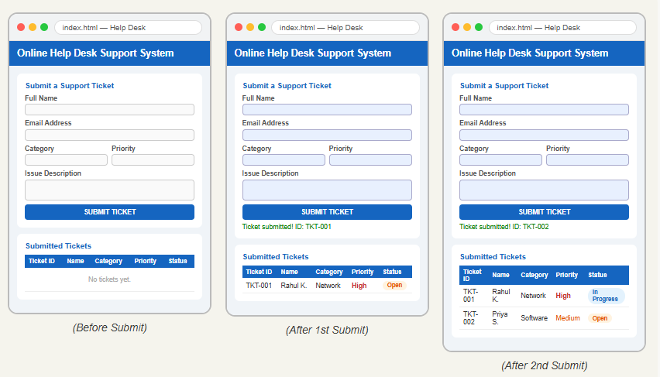

RESULT:
The Online Help Desk Support System was successfully developed and executed using HTML, CSS, and JavaScript. Users can submit support tickets with category and priority levels, and the ticket status can be updated dynamically between Open, In Progress, and Resolved states in a tabular dashboard.

